Documentation
Assignment 1
GEN-511
15th September, 2019

1. Problem Statement

2. Dataset Description

This dataset is originally from the National Institute of Diabetes and Digestive and Kidney Diseases. The objective of the dataset is to diagnostically predict whether or not a patient has diabetes, based on certain diagnostic measurements included in the dataset. Several constraints were placed on the selection of these instances from a larger database. In particular, all patients here are females at least 21 years old of Pima Indian heritage. The datasets consists of several medical predictor variables and one target variable, “Outcome”. Predictor variables includes the number of pregnancies the patient has had, their BMI, insulin level, age, glucose, blood pressure, skin thickness, body mass index, and the diabetes pedigree function. This is a binary classified data set.

- Exploratory Data Analysis

The data provided has 768 observations. Each observation has eight of the above described columns. Some of the cells contain NaN entries and some values were 0. Apart from the class labels, the value 0 in each of the cell is treated as a missing value. The table below shows the details of the above inferred information. The column Pregnancies has the maximum number of null values. In the section Data Preprocessing we describe the steps taken to handle this data and the experiments conducted on the data is described in the experimental scenario.
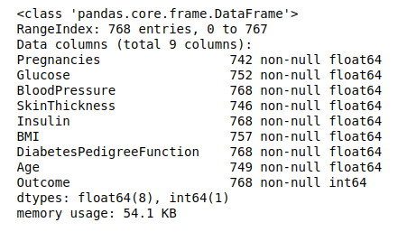Illustration 1: Data Information
Another observation that can be taken from the table is that blood pressure, insulin and DPF have no missing data. But they might have some zero values. They can be used assisting in finding correlation in the later stages of the assignment.

Moving further, we later present the data description in the illustration table 2. The data description shows up that apart from NaN value and 0, some attributes even have the minimum value as negative floating point integers. Also, in the given data, without any preprocessing, the values have approximately close mean and median values. Thus in the later part, we need to deal with these negative values of the attributes as well.

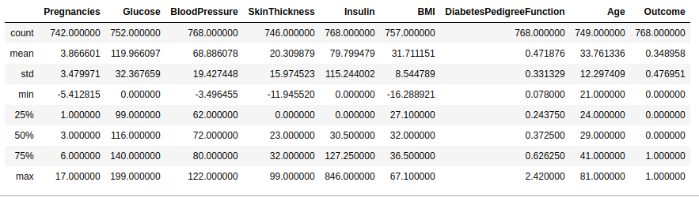Illustration 2: Data Description
We shall now be checking the correlation between each of the two attributes. For the instance, we replace all the missing and the negative values to 0. This was done because on handling the missing values by dropping them reduced the dataset to 292 values. This could have resulted in miscalculation from the current result.
Calculating correlation between the two attributes helps us to conclude the type of relation between the two attributes. This also helps us as some of the stronlgy related attributed could be feature engineered in the further part of the assigment to form a new feature. Correlation may also help us in filling up the missing data as the data set can be sorted with respect to the strongly correlated attributes and later the values of the missing cells could have been taken from the neighbour cells.
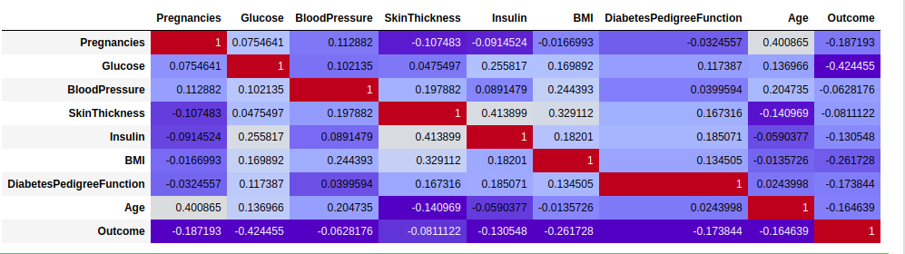
Illustration 3: Correlation Matrix

From the above table, some of the clear observations are that insulin level in the body is strongly correlated with the skin thickness of the patient. Also the pregnancy of the patient goes along with the age. Calculating this correlation matrix gives us a deep insight between how connected the corresponding attributes are.

- Data Preprocessing

As discussed in the above section, the PIMA Indian diabetes dataset contains missing and random values. Some cells even have the negative values. We replaced these negative values, 0 and null values with NaN. One evaluating the number of cells having NaN values, we find that at most 374 observations of insulin attribute have NaN value. Overall, there are only 292 observations with complete data. Dropping this data will lead to a huge loss of information. In the later sections, we showed the experimental results after dropping the null values and by replacing these null values with optimum fillers.

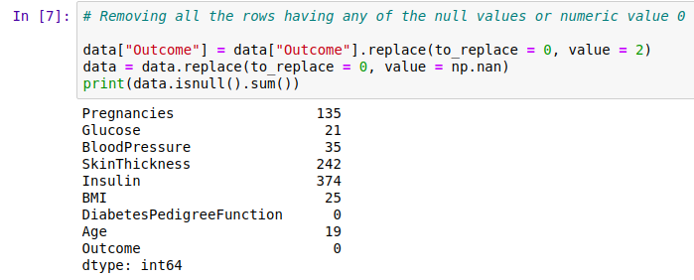Illustration 4: NaN values per attributes
We now fill the missing data values. For imputation, we chose three basic methods.
- Mean: We computed the mean of the remaining observations left in the attribute and filled the missing values with the mean. This is the most basic approach and it requires the least overhead time. One of the drawback of using mean is that it reduces the variance. But this can also be taken as a silver lining as an easy hyposis would even work in this case. Another reason of replacing the data with mean value was as in the given dataset, the mean and median values are approximately equal. Thus choosing these values gave us the best of both the worlds.

- Sklearn.preprocessing Impute.SimpleImputer: The scikit-learn library provides the Imputer() pre-processing class that can be used to replace the missing values. It is a flexible class that allows you to specify the value to replace (it can be something other than NaN) and the technique used to replace it (such as mean, median, or mode). The Imputer class operates directly on the NumPy array instead of the DataFrame. This uses a predictive model to find the best value to be fitted in the position.

- Tweaked Rand(): Another method to impute the missing value was to fill the required location with missing values. We tweaked the method by calculating the minimum value and the maximum value of each attribute and later filled the missing value with a random value in the given range.

- Feature Extraction

After filling the missing values and conducting experiments

3. Experimental Scenario

4. Results

